**Exhibition:**

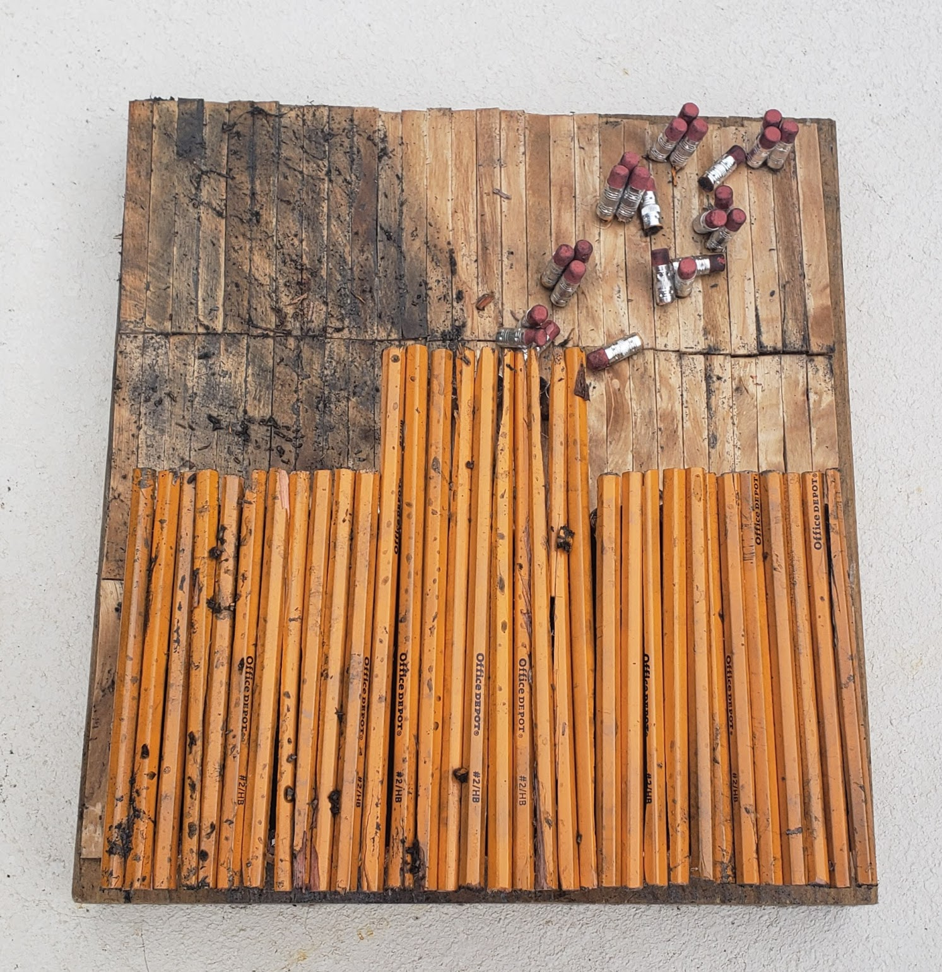

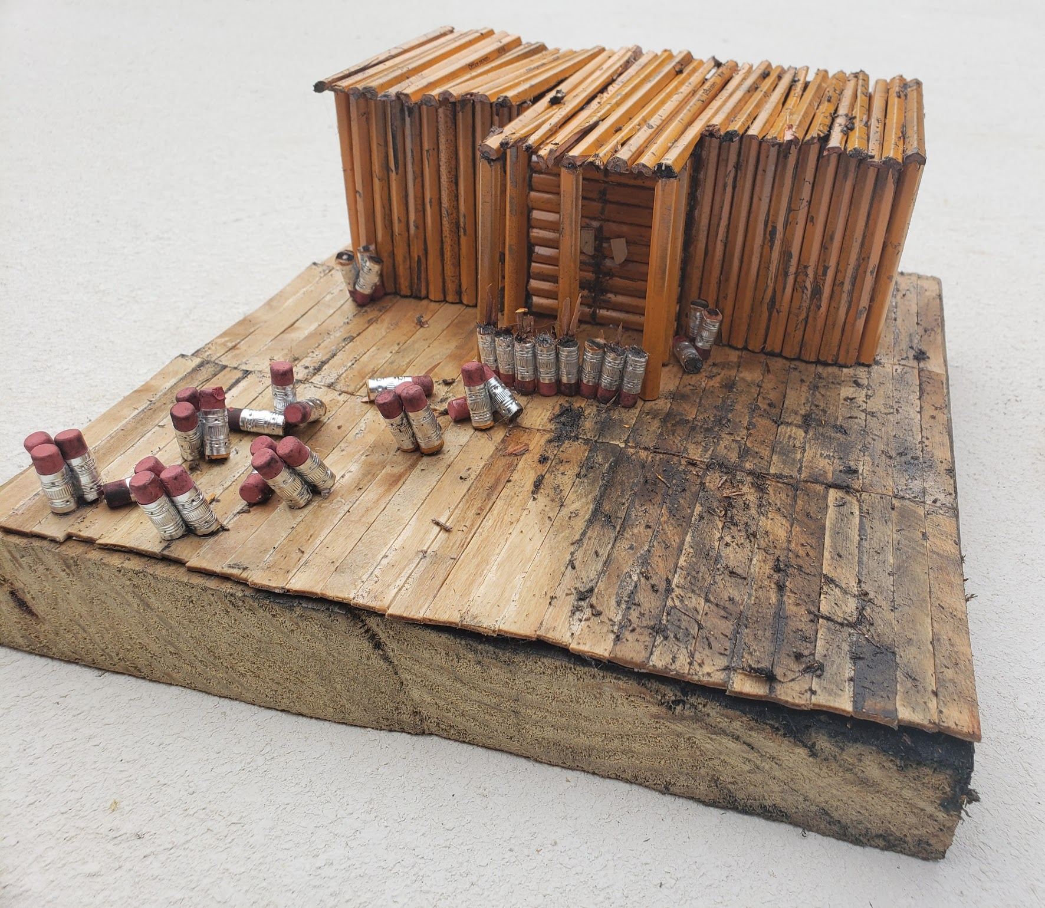

**Title: The Devastation in the Wake of Fire**

**Medium: Number 2 pencils (bought 13 cases of 12 pencils), popsicle sticks (already owned), eraser heads (comes with the number 2 pencils), E6000 glue (bought), graphite remnants (made by use of number 2 pencils), 30.48 by 30.48 by 5.08cm wooden platform (already owned)**

**Size (centimeters): 30.48 by 30.48 platform and height of 15.24cm**

**Intentions of the Work: The house looks burnt and damaged to represent the California fires. I drew upon my own personal fears and experience to create this artwork. Most of my mother's family lives in California. Every time I hear about a wildfire in California I fear for my family and imagine my family going through the destruction in this artwork. I designed my sculpture with this fear. In fact, my sculpture vaguely resembles my own house to symbolize the damage the California fires could have to family.**

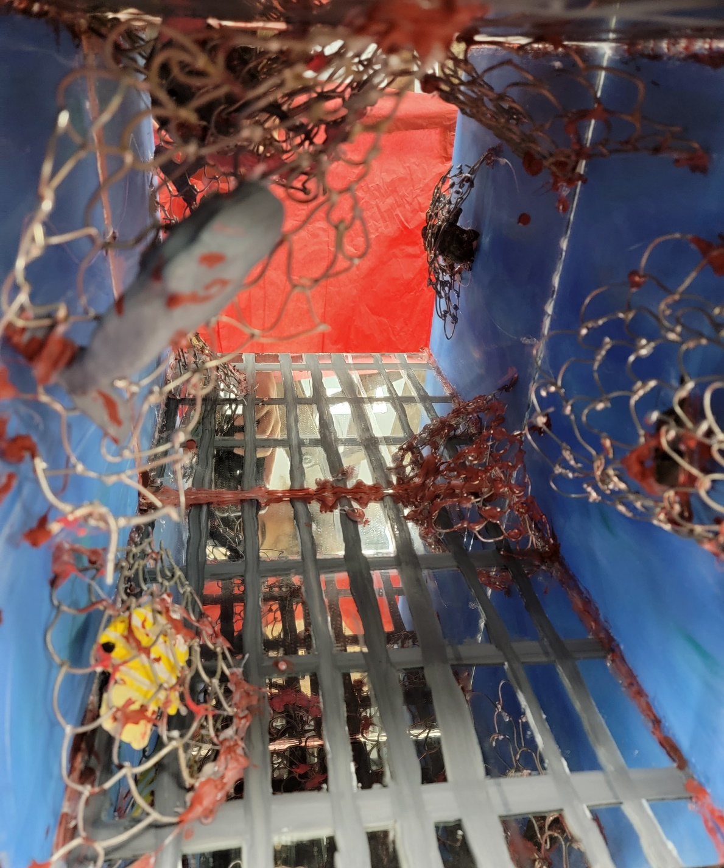

**https://sdhc.instructure.com/files/55255357/download?download_frd=1&verifier=7TnvK7mAAkB5kikiJPWndqziDjyYaIzWe3BvYf26**

**Title: Human’s Ocean**

**Medium: 5 30.48 by 30.48cm mirror panels (bought), solder (bought only half of solder used the rest was already owned), acrylic paint (already owned), paper clay (given as part of art supplies from class), hot glue (already owned), white gesso (bought), E6000 fabric glue spray (bought)**

**Size (centimeters): 30.48 by 30.48 by 30.48**

**Intentions of the Work:** **This artwork is a representation of humans continued use of illegal nets and netting of endangered animals. I drew upon my own love of the ocean and its creatures for this artwork. Human greed and selfishness damaged the oceans. I want people to realize that all their fun at the beach and in the ocean can be dangerous if trash or fishing nets, pollution and other factors are not considered. Imprisoning people within similar cruel conditions needs to be changed as well. Actions have consequences.**

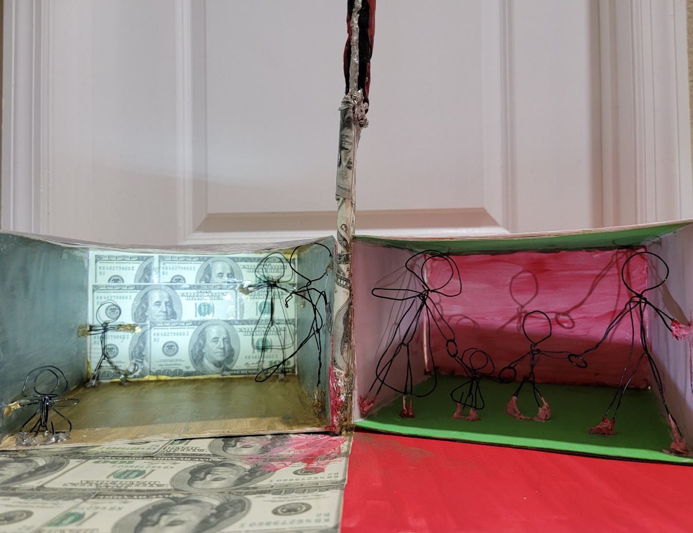

**https://sdhc.instructure.com/files/55214886/download?download_frd=1&verifier=4eTNQTAmdbeMfNyCHKwkQCaDxt9m681kxrpad8GE**

**Title: Greed’s Destruction**

**Medium: Acrylic paint (already owned), E6000 glue (bought), grey wire (bought), solder (bought), paper clay (given as part of art supplies from class), printer paper with 100-dollar bill designs (printed on my printer), thick white**

**Size (centimeters): 22 by 17 by 15 (height)**

**Intentions of the Work: This artwork is a statement on how greed especially in America has pulled apart so many families. Greed has hurt so many people throughout history such as in war, poverty, and depression. Personally, I have seen so many people and families pulled apart by money. The capitalist society within America is great for the economy but can be hurtful to familial bonds. Familial bonds should not be based on monetary value but on actual love. After all money is not everything, family is more important.**

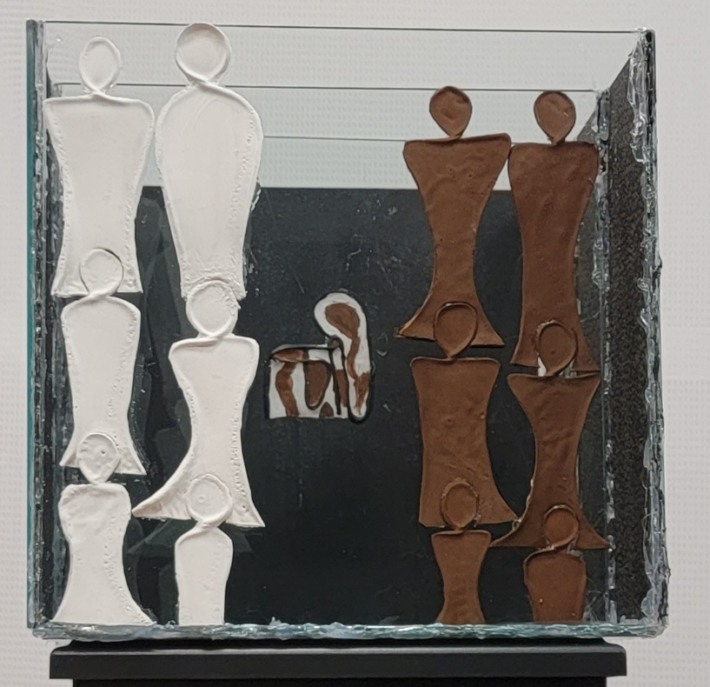

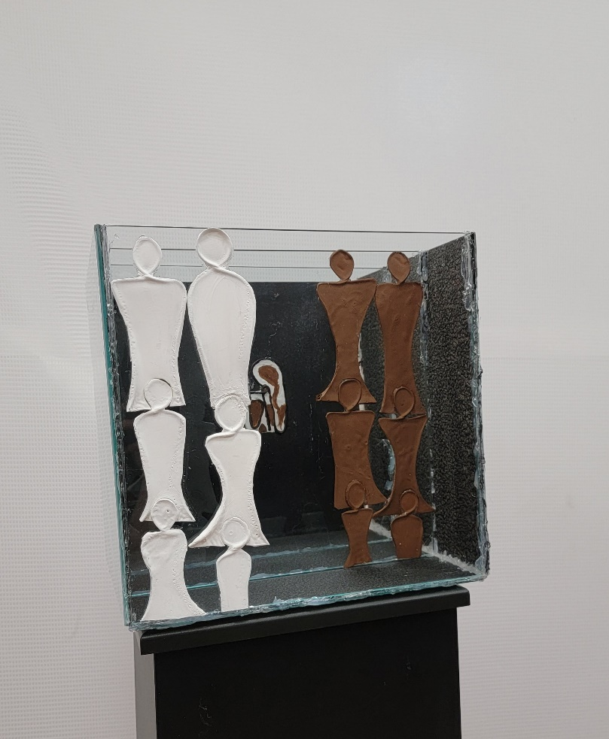

**Title: Thoughtless Division**

**Medium:7 30.48 by 30.48cm glass panels (bought), Elmer’s glue (already owned), sculpting wire (bought), acrylic paint (bought), hot glue (already owned), E6000 glue (bought), white gesso (bought)**

**Size (centimeters): 30.48 by 30.48 by 30.48**

**Intentions of the Work: As a multiracial (Black, White, and Asian) person, I can say that when your parents are of completely different backgrounds you often feel like you must pick a side to associate more with. There is always pressure to be more like one culture than another. But these differences especially among white and black people isolate the children who are both come with the isolation and loneliness of not fitting in with one cultural group. We need to stop this isolation and try to be more open-minded.**

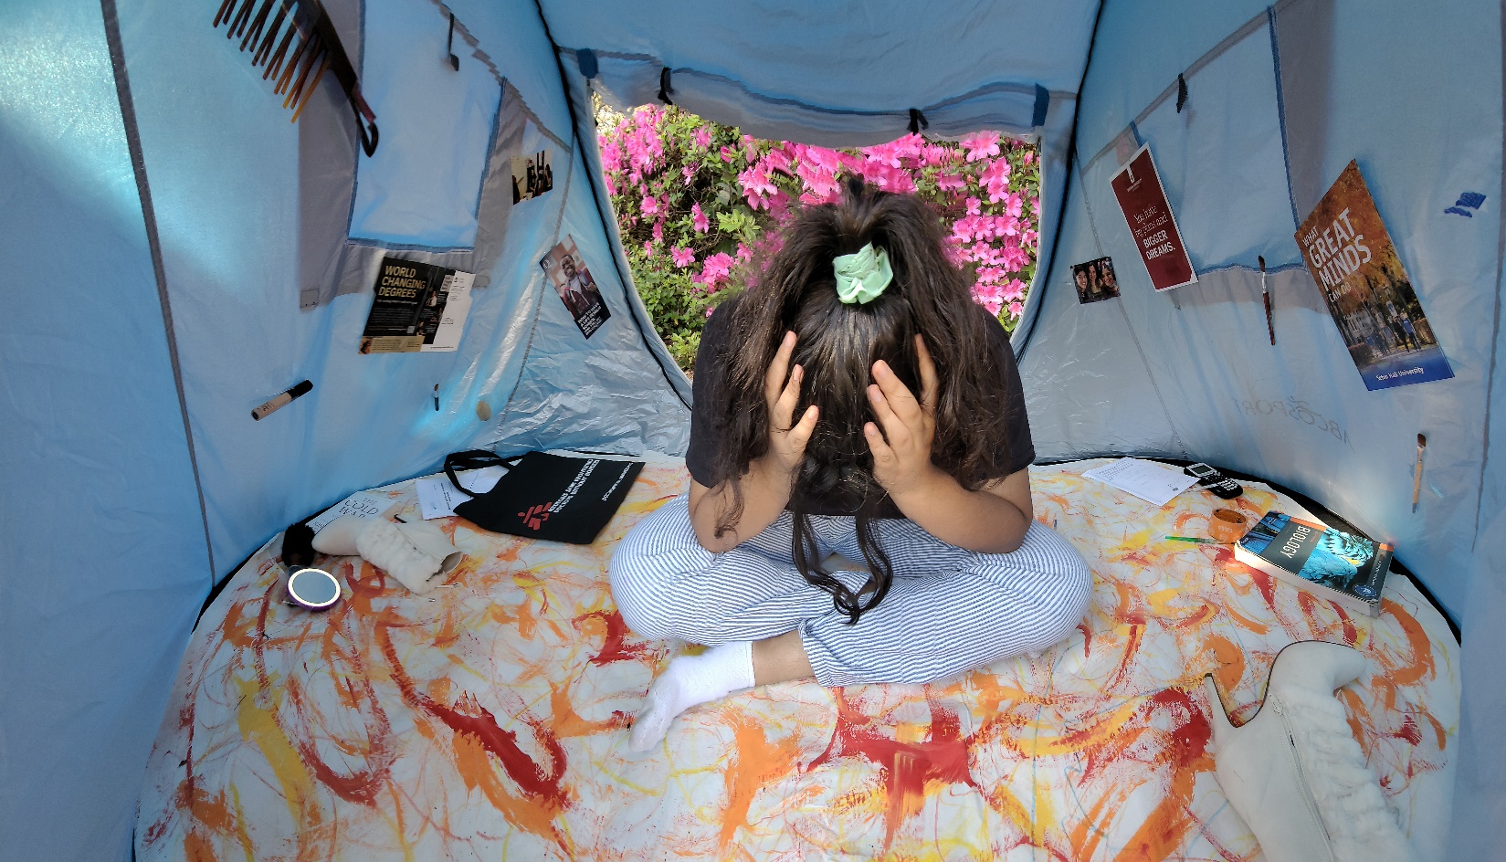

**Title: Chaos Within the Mind**

**Medium: photography**

**Size (centimeters): 6320 x 3616**

**Intentions of the Work:** **I drew upon my struggles with being a IB female senior in high school. The pressure to pick a college, the workload of IB and societies expectations of what being a girl means is hard to deal with. I must figure out where to go to college that is safe and close enough to family. Then make sure that I am accepted by society as a woman so that I can get jobs and look the part when applying for college or going to social gatherings. It is hard to keep up and all this crowds the mind.**

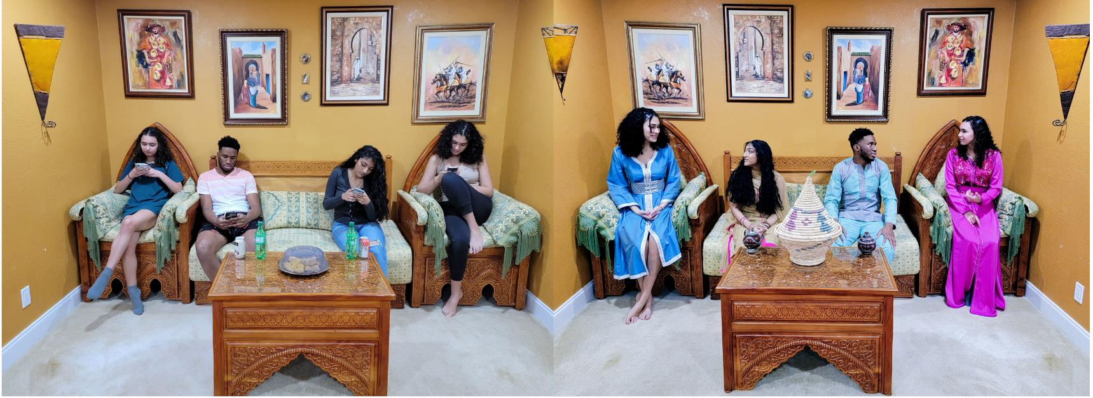

**Title: Lost To Technology**

**Medium: photography**

**Size (centimeters): 1727 x 625 2.3 MB**

**Intentions of the Work:** **This artwork is a commentary on the growing problems caused by developing technology especially a loss of communication without technology and loss of older culture due to popularity of fashion. People become attached to their phones both to communicate and fit in with the crowd physically. This attachment led to our losing knowledge of how to communicate without their technology and to our culture. We need not only connect with our roots but also remember how to communicate without technology.**

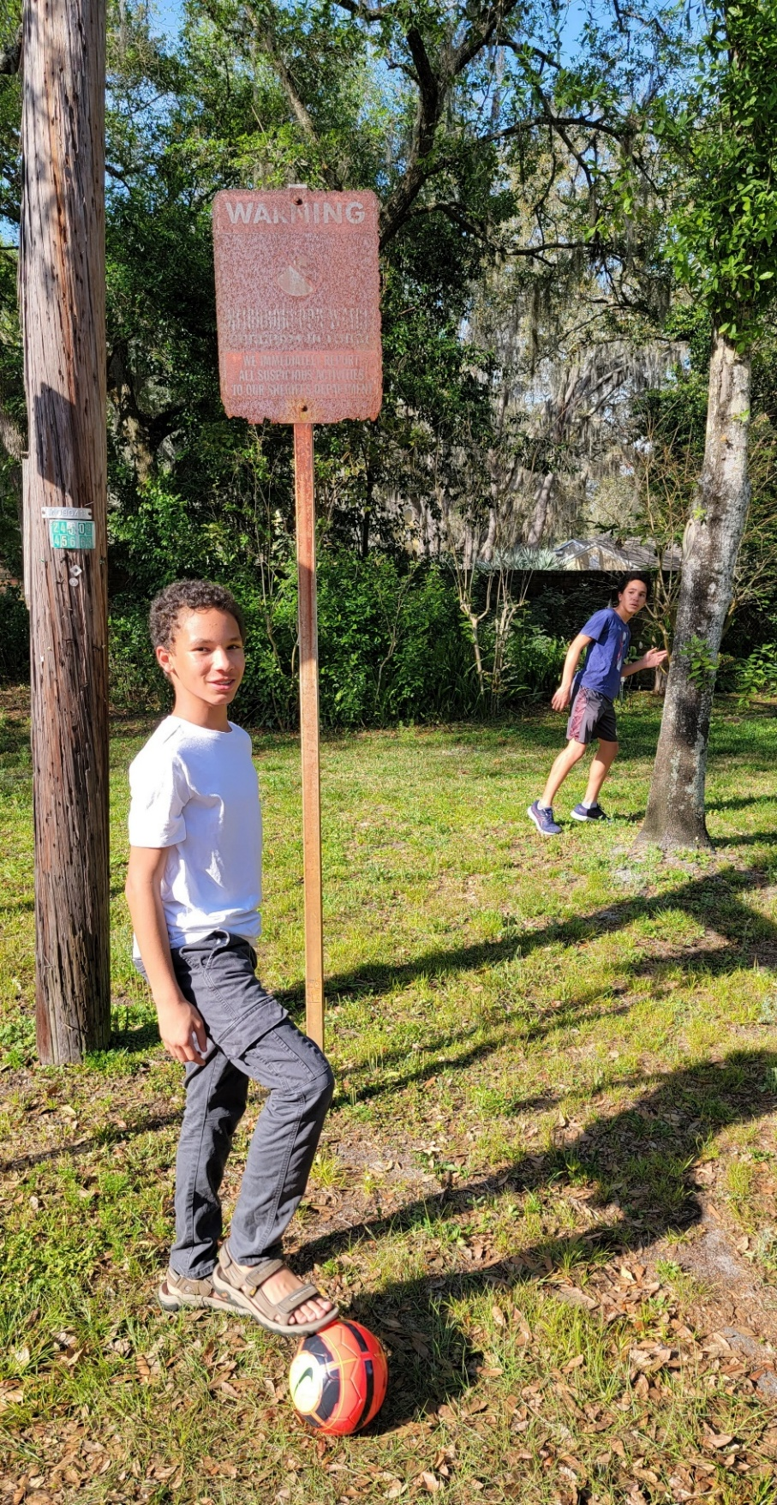

**Title: Fear For The Future**

**Medium: photography**

**Size (centimeters):** **2039 x 3947 4.2 MB**

**Intentions of the Work: When I was younger, I could run and play in the streets. But it seems as if as I got older there was more to be afraid of. The news reported more and more dangerous human caused tragedies. The older I got the more afraid I became of what dangers the future would carry. The models in this picture represent this contrast of when I was younger verses now. To understand the message of the more fear seen in the future you must look closer to see another boy running in fear in the background.**

Exhibition images

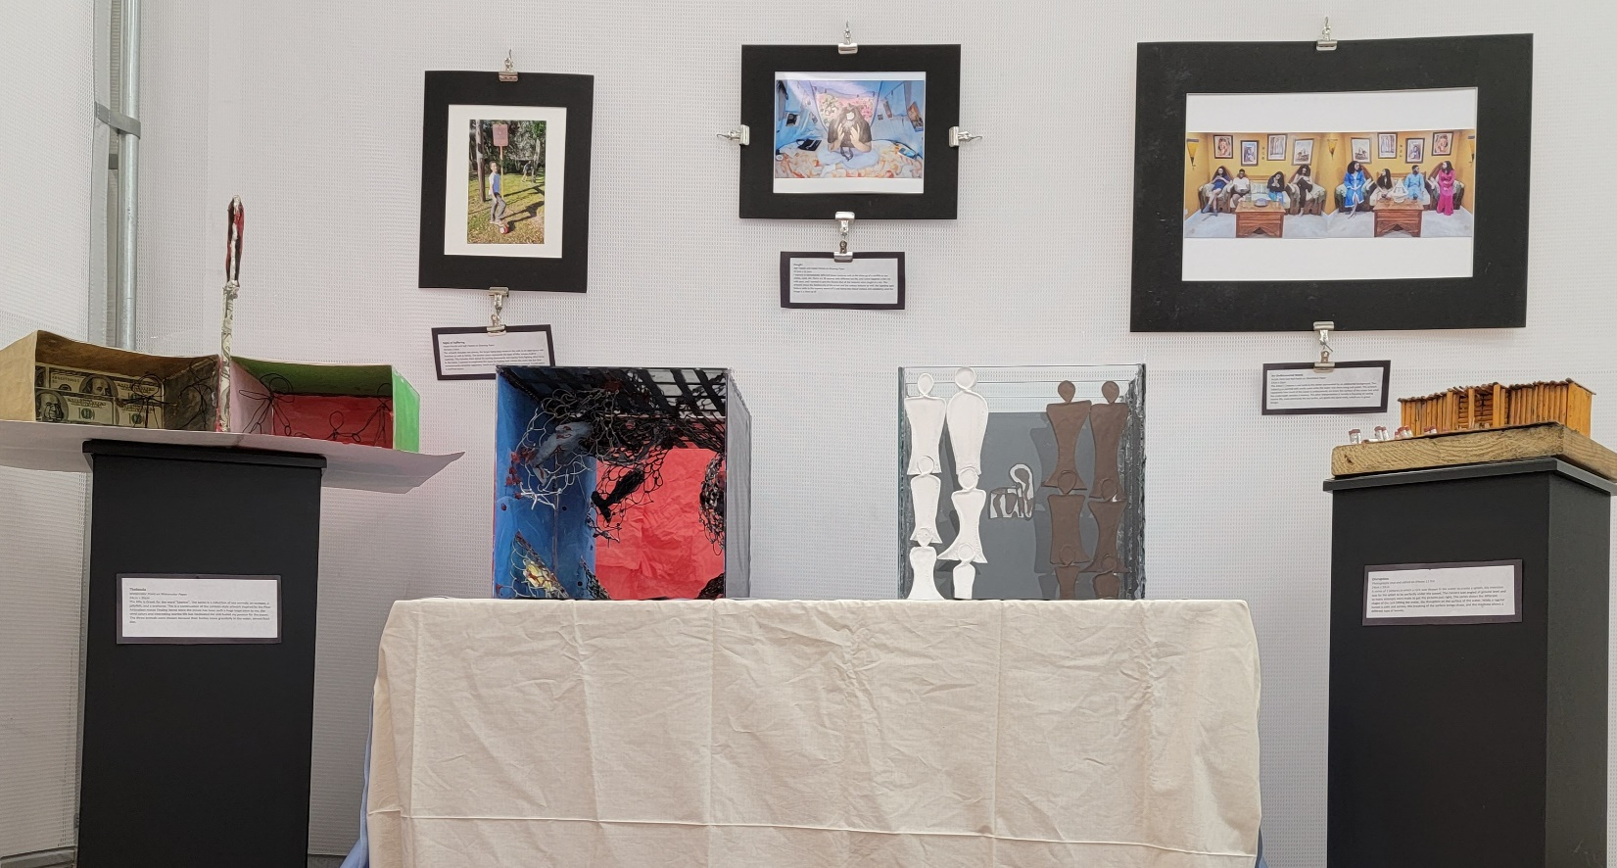

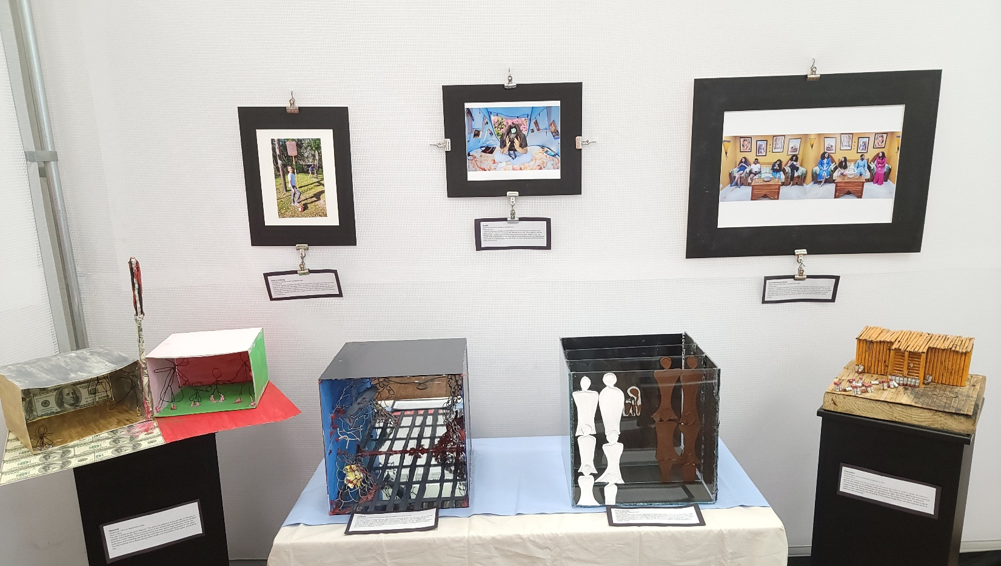

**Curatorial Rationale**

**HL student**

Within my exhibition my vision was to create an experience for my viewers. I want them to have to look a bit closer for the specific details found within all my artworks. My selection of these particular artworks was based on the fact that these were my best artworks, and they all deal with human flaws or human caused societal issues. I want my art (shown) to have a purpose in bringing awareness to issues important to me and hopefully make them important to others. These flaws (greed, reckless fires, loss of communication/culture, loss of security, mental stress/pressure from society, and societal divisions based on cultural background) are important to me and have personally affected me in one way or another. I organized all my artwork by how all my artwork is connected to me and whether it is 3 dimensional. From right to left (similar to reading) my sculptures are organized from least personally painful to most. Greed’s Devastation, while I have seen this devastation first hand it was not as painful for me personally and more simply expected. Human’s Ocean is very painful for me because animals are completely innocent, I tend to like animal more than people most of the time. Thoughtless Division is one of the most personal since I am a product of this thoughtless division as a multiracial person. Lastly, The Devastation in the Wake of Fire caused the most pain and fear for me since my family means everything to me and seeing them in danger is terrifying. My photos are arranged in the same order, Fear For The Future, Chaos Within the Mind, and Lost To Technology. I made sure that my exhibition photos made the viewers somewhat uncomfortable. I want my viewers to be uncomfortable so that they investigate what is making them uncomfortable and are ultimately faced with their own human and societal flaws. I made sure that these flaws were seen in this order since the red within Greed’s Destruction was a similar red found within the reflection of Human’s Ocean. The box shape is then flowing into Thoughtless Division with its frosted (hot glue) edges that contrast with burnt appearance of The Devastation in the Wake of Fire. Fear For The Future has a boy in a blue shirt in the background flows into the blue membrane of Chaos Within the Mind, which has pink flowers in the background that matches the dress of the girl on the right side of the photo Lost To Technology. The warm colors of the floor and blue membrane match the colors found within Lost To Technology as well. My entire exhibition is based on facing the human flaws that have torn our society (especially America) apart, I want change to happen. I want my audience to feel guilt, understand our flaws, and learn that we need change. I also want my audience to feel a personal connection to at least one of my artworks since they portray common tragedies and fears. Although it may not happen overnight, I hope I can bring more awareness to these issues that have personally impacted me as well as many others. I want my audience to consider how they can change and how they can bring about this change so that less of these fears and tragedies occur.